Michael Trapp

5/4/2024

MARS2001

Understanding the Current State of Seagrass in Moreton Bay

*Introduction*

Seagrass is an extremely important and sensitive habitat for carbon productivity and sustaining organisms. It is affected by human and natural interactions such as turbidity, storm events, and runoff, as boating, coastal development, and dredging (Andrew K. Cuttriss). 50% of Australia’s seagrass has been destroyed due to dredging or pollution (Wildlife Preservation Society of Queensland). In the western bay of Moreton Island, seagrass is restricted to shallower waters due to the turbidity of the water (Department of Environment, Science and Innovation), and the shallower it is, the more likely it is to be disturbed by human interaction. Residents’ concerns of decreasing seagrass coverage due to boating and human foot traffic on the tidal plains was brought to attention and observed. The goal of this survey is to measure the changes in species composition from the shoreline and parallel to the shoreline, investigate the changes in percentage cover from and across the shoreline, compare the height of the seagrass, and compare the state of the seagrass at different depths in Moreton Bay. It is hypothesized that seagrass health has slightly reduced over the years.

*Methods*

Survey was conducted at high tide out the front of Moreton Bay Research Station, it is important to note the season, as it was conducted in early April. An overview of the Moreton Bay’s Research Station states “Moreton Bay has hot, wet summers and mild, dry winters, with average daytime temperatures ranging from 21°C to 29°C year-round. The south-east trade winds dominate most of the year, with occasional westerlies and northerlies in winter and summer, respectively. The bay has two daily tide cycles, with a maximum range of approximately 2.5 metres” (University of Queensland). The tidal range for the day was 0.1m at low and 1.1m at high. On this day (April 5th) high tide was at 6 am; The survey began approximately 7 am and the survey was finished at approximately 9:30 am. A transect line 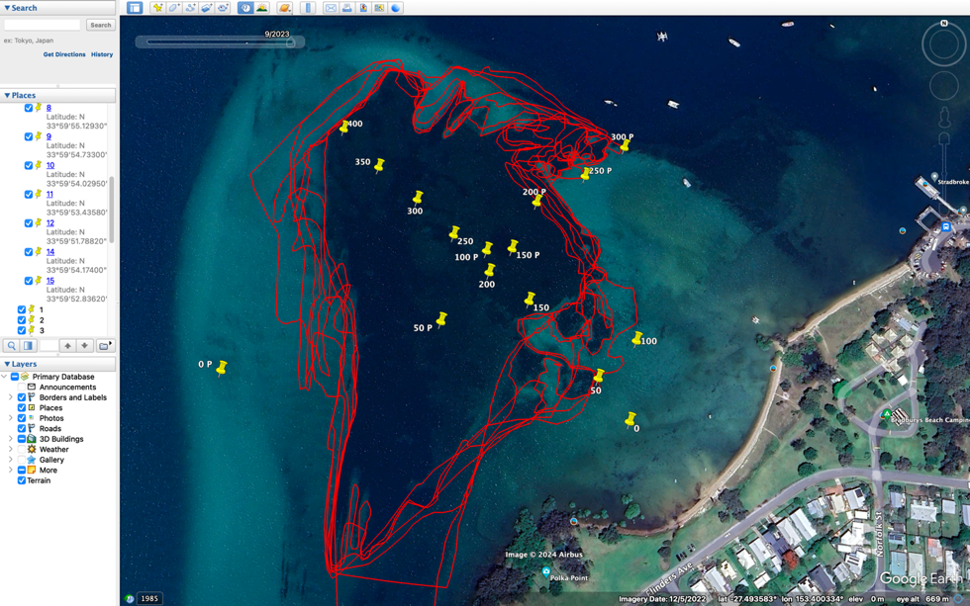(Transect 1) with a length of 400m, ran perpendicular to the shore (South-East to North-West), and a second transect line (Transect 2) with a length of 300m ran parallel to the shore (South-West to North-East). Two groups ran parallel surveys along the transect lines, effectively doubling the data points available. Conditions for the day were cloudy with on/off rain, no waves, turbid water, and 24 °C.

Figure 1: spatially shows seagrass coverage from 2014-2024.

For each group, two teams of two alternated doing the survey in-water, with one member remaining in the vessel noting depth and co-ordinates for each site. Depth and Location were taken from the echosounder and GPS of the vessel. At each site, spaced 50m apart along the transect lines, the in-water team took 3 random quadrant measurements, noting the dominant and present seagrass species, sediment type, percent coverage, and mean length of seagrass for each quadrant. For each quadrant, anything noteworthy was also recorded in a separate column. After field work was complete, Google Earth Pro was used to track the boat’s movement using the GPS coordinates written down and converted to degrees-minutes-seconds format to be compatible with Google Earth Pro. The marker tool was used with each longitude and latitude point being labelled and marked appropriately to mark the sites at which each data sample was taken, aimed to be at 50m intervals along two perpendicular transects. The purpose of this visualization was to mark and trace the boat’s movements and to give coordinates and satellite representation of each site along the transect line.  Google Earth Pro polygon tool was used to find the area of seagrass off Dunwich.  Data was collected from 2014-23, the years 2020, 2019, and 2017 did not provide a high enough spatial resolution to accurately gather data.

The equipment used included three slates and corresponding pencils for notetaking during field observations. A single ruler and sharpener were provided for measurements of seagrass length, and the maintenance of writing implements. Ten sheets of waterproof paper were allocated for documentation purposes. The team was equipped with nine pairs of fins, wetsuits, masks, and snorkels. Spatial analysis was conducted using two 1m2 quadrats along with Garmin ETREX 22X GPS devices for positioning. Photos were taken with two GoPro Hero 9 Black cameras, each enclosed within waterproof casings with handles, along with a TG6 Olympus Camera. Navigation during the study was enabled by the boat’s GPS system, while the boat echosounder was used to map the depth.

*Results*

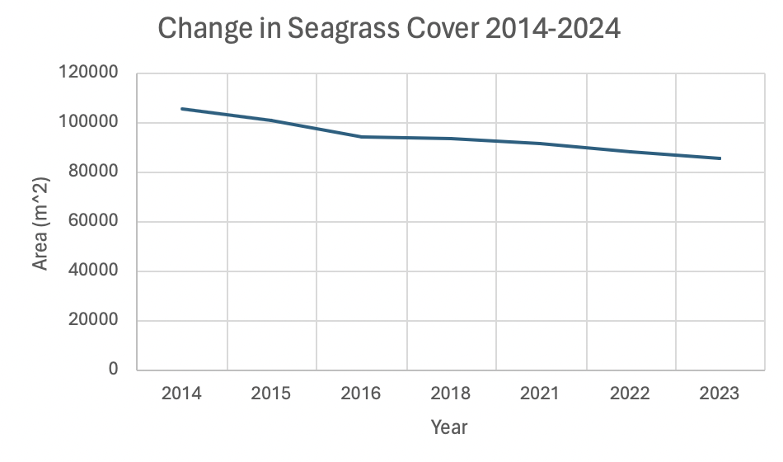

Figure 2: Seagrass coverage from Figure 1 calculated as m2 from 2014-2024.

The figure above displays the total area of seagrass from 2014-2024, this is the data gathered from Google Earth Pro. This data gives a good estimate of recent trends in seagrass growth, but due to quality issues mentioned previously it should be taken as an estimate. These issues also included troubles with satellite imaging such as dark patches of sand being mistaken for seagrass and in lighter or less dense areas, seagrass may not have been included. In addition, seasonality limits the accuracy of these findings because seasons effect growth, in summers seagrass beds are often fuller and larger than in winter (Stewart). The data collected was not from the same month each year, creating a somewhat inconsistent data set.

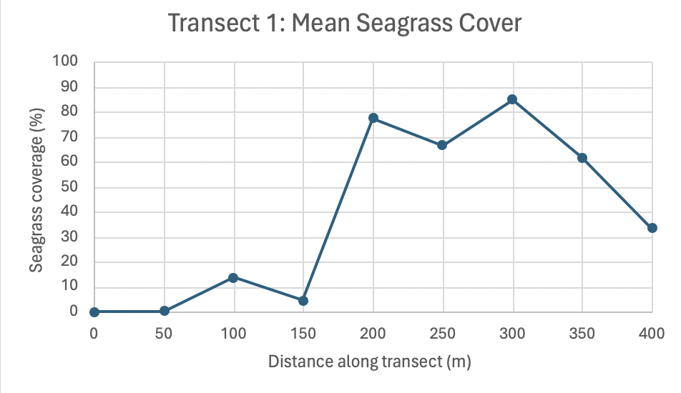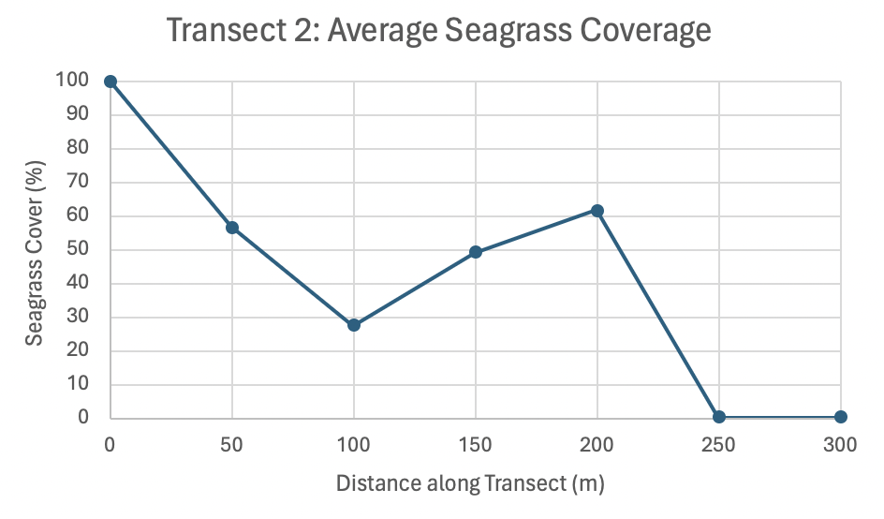

In Transect 1, the mean seagrass cover increased approximately 150m from the shore, then decreased after 300m from the shore. There was a positive relationship between percentage cover and depth shown in the following graphs. In Transect 2 there is a general decline in coverage with the exception at 200m.

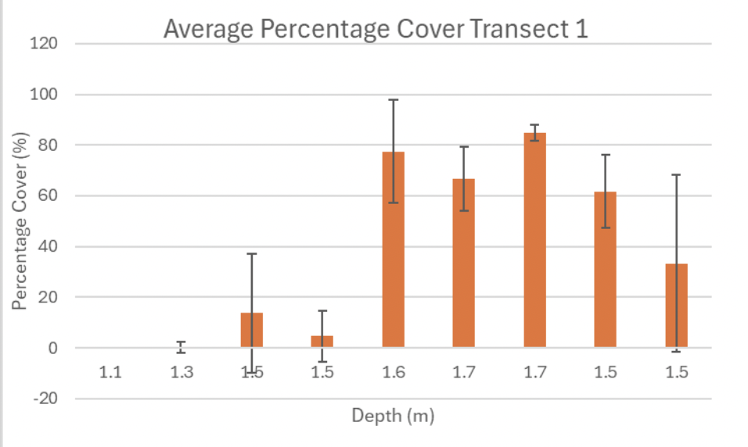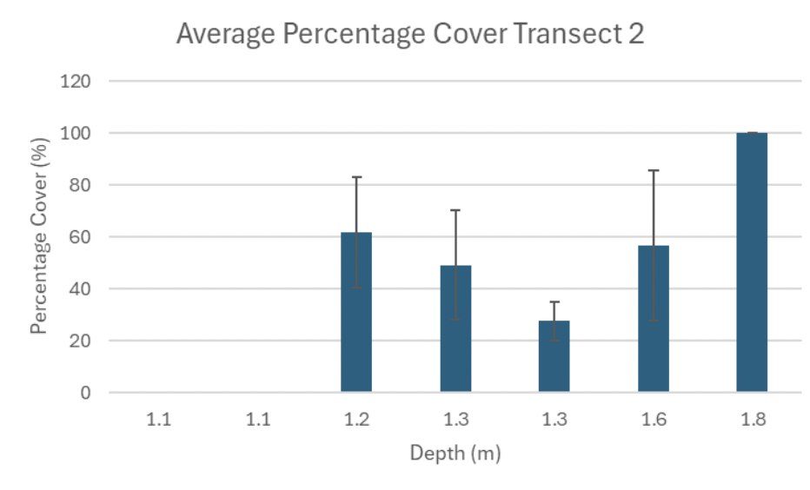

For the average percent cover vs. depth, it shows in Transect 1 that at 1.5-1.7m, percent cover is higher than anything shallower. In Transect 2, anything over 1.1m contains fuller coverage. In both sites anything under 1.2m is little to no growth. Error bars are very large and there is no statistically significant data between points because the error bars overlap. High error is due to varying locations, human error (such as not swimming straight), systematic error, large variation over small areas, and inconsistent methodology.

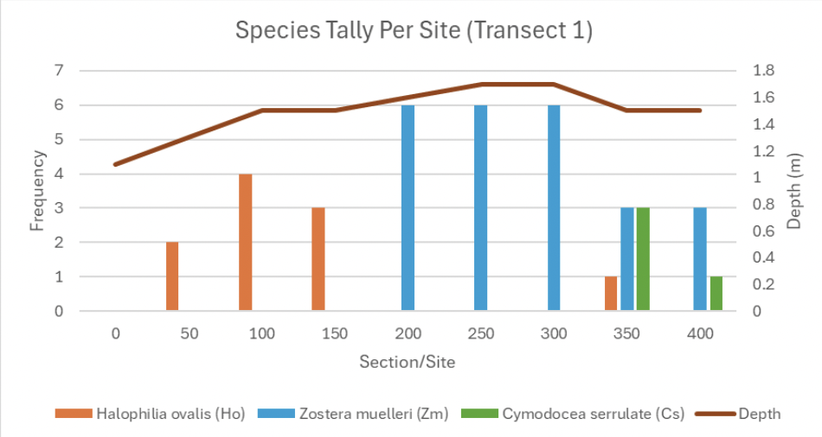 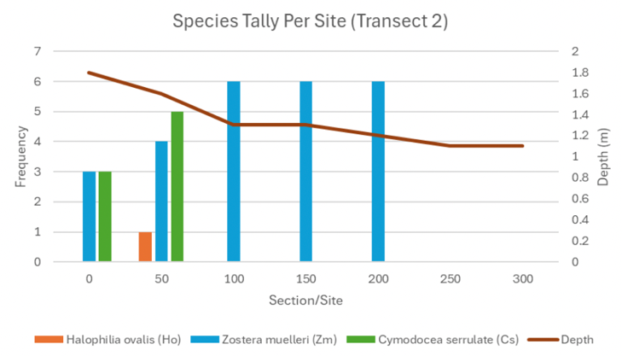

In Transect 1 is generally more diverse, containing notable amounts of each species. *Halophilia ovalis* (Ho) prefers growth closer to shore, while *Cymodocea serrulate* (Cs) is found further from the shore. It is also observed that Cs prefers more compact sediment. *Zostera muelleri* (Zm) outcompetes the other two in the middle of the transect. This is also observed in Transect 2. At 0m and the end point we exceed the range of seagrass cover. In transect 2, all three species were found in 0 and 50m, then after 100m only Zm was found.

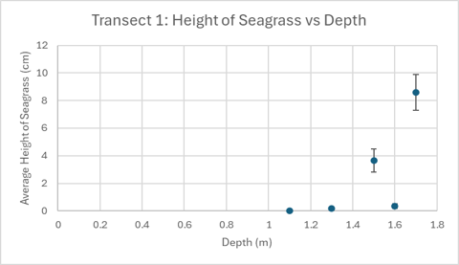 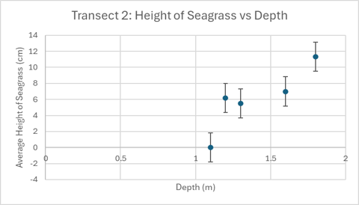

These figures clearly show that as depth increases, so does seagrass height. During data collection the tide was on its way out, but the data does not reflect a significant change in depth between the two transects, as their data is very similar.

*Discussion*

The most notable piece of data was the total seagrass coverage over the years. This data was not collected from our field work but using Google Earth Pro, this is the most substantial data because it proves the hypothesis through a longer timeframe and allows us to see more long-term changes. The observational data that was gathered is still relevant but due to large errors and inconsistent methodology, the data gathered from the field cannot be interpreted in correspondence to the posed hypothesis. It may give hints to why seagrass health has declined, but much more data is needed. The most prominent data from the field is the main seagrass species present, which were *Halophilia ovalis*, *Cymodocea serrulate* and *Zostera muelleri*, as well as the specific locality and density of seagrass in the study area. Zm becoming the dominant species could be due to a lack of light, sediment, more wave energy, boats, flooding, or runoff. Seagrass is limited to fewer species in poorer water quality (Moreton Bay Foundation), and Zm being a more opportunistic species would explain why it is the dominant species observed in both transects. Seagrass in relation to the shoreline is best seen through Google Earth at Figure 1, as the study only gathers data from this year, but Figure 1 is a compilation of the seagrass beds over the years. As the sandbar shifts and moves, the ideal depth for these seagrasses will as well, but the reduction of seagrass coverage cannot be attributed to simply a loss of sediment. Many factors contribute to the overall health of this specific seagrass bed and since 2014 there has been a slight reduction in coverage, but the study does not have the capacity to answer which factor has attributed the most as this would take considerably more data within a longer timeframe.

*References*

Andrew K. Cuttriss a, et al. “Seagrass Communities in Southern Moreton Bay, Australia: Coverage and Fragmentation Trends between 1987 and 2005.” *Aquatic Botany*, Elsevier, 23 Mar. 2013, www.sciencedirect.com/science/article/pii/S0304377013000417?via%3Dihub.

“Coastal Citizen Science.” *Wildlife Preservation Society of Queensland*, wildlife.org.au/our-work/conservation-programs/coastal-citizen-science/. Accessed 1 May 2024.

“Seagrass: Moreton Bay Marine Park.” *Parks and Forests | Department of Environment, Science and Innovation, Queensland*, jurisdiction=Queensland; sector=government; corporateName=Department of Environment, Science and Innovation, 16 Apr. 2024, parks.desi.qld.gov.au/parks/moreton-bay/zoning/information-sheets/seagrass.

“Seagrasses of Moreton Bay Quandamooka: Diversity, Ecology and Resilience.” *Moreton Bay Foundation*, 15 Dec. 2023, moretonbayfoundation.org/articles/seagrasses-of-moreton-bay-quandamooka-diversity-ecology-and-resilience/.

Stewart, Mark. *Seagrasses*, www.dpi.nsw.gov.au/__data/assets/pdf_file/0019/203149/seagrasses-primefact-629.pdf. Accessed 1 May 2024.

University of Queensland. “Climate.” *The University of Queensland*, 18 Nov. 2020, www.uq.edu.au/moreton-bay-research-station/about/climate#:~:text=The%20bay%20has%20two%20daily,range%20of%20approximately%202.5%20metres.